**WHATSOPEN**

**PROJECT MANAGER'S REPORT**

**Instructions for accessing project on GITHUB**

**Michael Kravtsov**

Project Manager

**Munjal Thakore**,

Engineering Manager

**Ahmed Ali Syed**,

Programmer/ Developer

**Mohammed Mudassir Ali Syed**,

Programmer/ Developer

STEP 1: Go to WWW.GITHUB.COM

Or Click here <https://github.com/>

STEP 2: If you have an account just sign in or sign up as a new

member for GitHub.

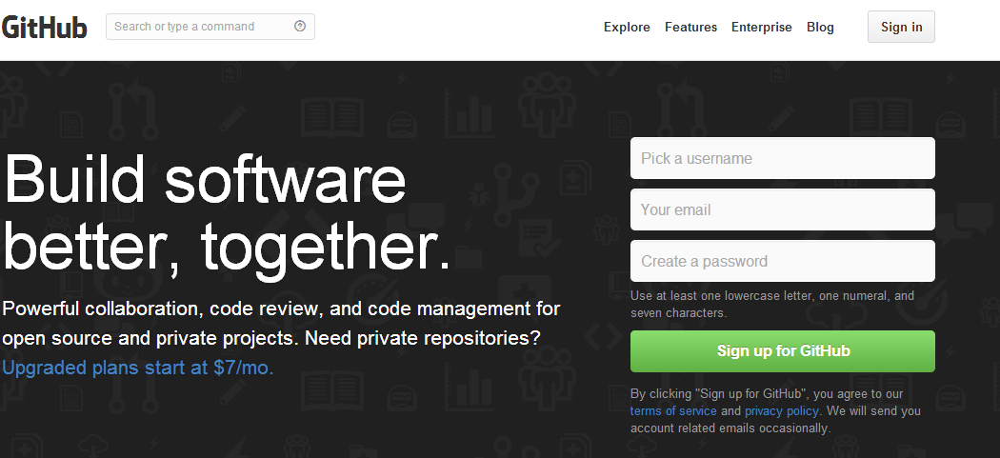

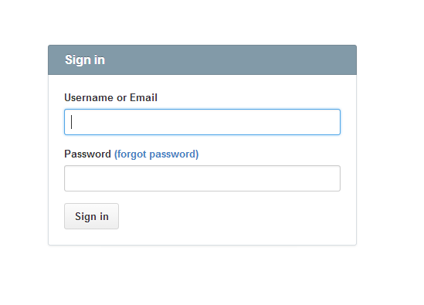

STEP 3: After logging in successfully, you are allowed to make

your own repositories and add collaborators to a particular repository

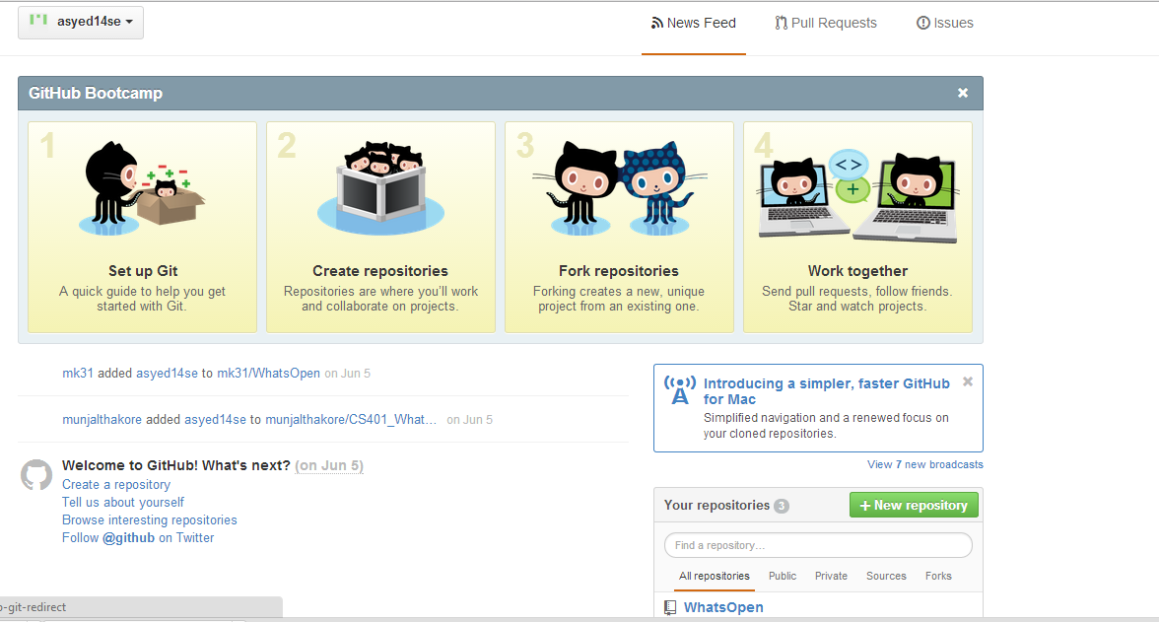

STEP 4: Select the repository(WhatsOpen) and you will see the files in repository that you can access

